CEO REPORT [Template]
10 January 202X

METRICS

Sales and Marketing | Financial | Operations
Premium customers won 23  Premium customers lost 1  Net Prem. Revenue Gain (monthly) $48K  Total customers won 156  Total customers lost 17  Net Prem. Revenue Gain 98$K | Sales Revenue $955K  Operating Profit $98K  Net Profit/ Loss $46K  Cash Collected $1.04M  Closing Balance $411K | CRM Implementation On-track  HQ Refurb Off-track  Systems Merge project On-track  New HR Policy On-track

KEY DECISIONS / DISCUSSIONS
To be made by board | for input

- List main topics you want board to consider this meeting and ensure on agenda

TOP OF MIND
Areas of focus or concern for CEO

- List whatever business issue(s) are keeping you up at night OR most exercising your mind

BIG WINS | LEARNING

List a few big wins or key learnings achieved this quarter.
I.e. a major new channel partnership

CEO SUMMARY

Add a few sentences to summarise position and direct attention of board to what you see as most important.

- [NAME] OF NEXT LEVEL OF KEY METRICS
(Insert your own metrics graphs)
Revenue and Customer Overview 202X
(Graphs provided by www.datapine.com)

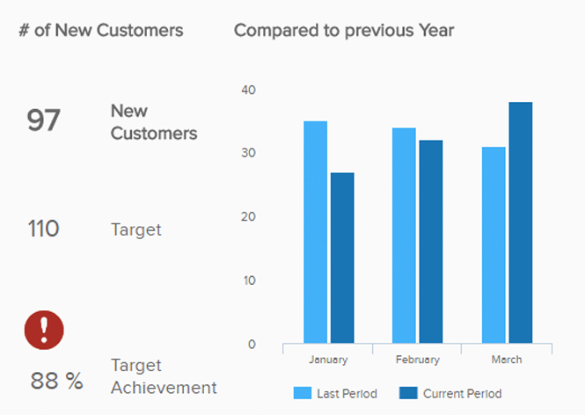
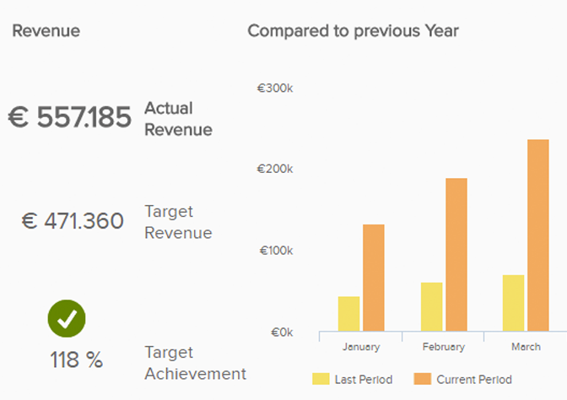

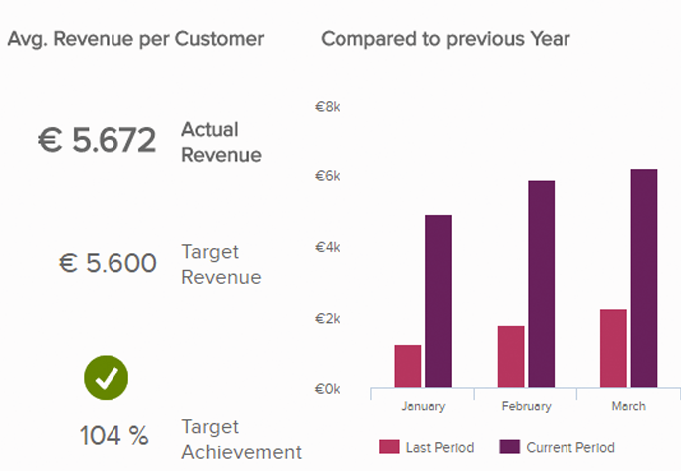
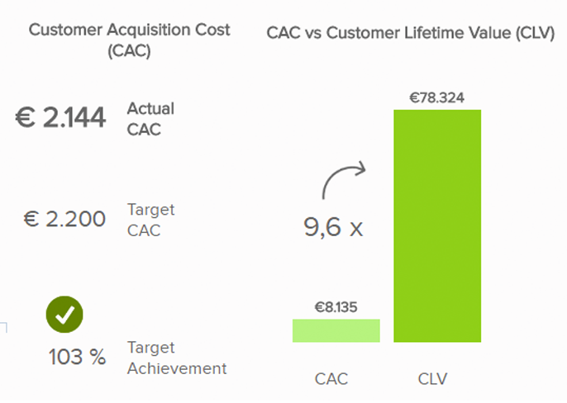

GRAPH | METRICS COMMENTARY
Add commentary as required

- [NAME] SNAPSHOT REPORT
Insert next level of key business metrics here.
e.g. ANNUAL Programme Update / Issues
Area | Qtr. July - Sept | Month Report
- Governance and monitoring | Task at hand | Update / Issues
1.1 Compliance
1.2 Audit / AGM
1.3 Strategy
1.4 Training / Opportunities
1.5 HR
- Membership Services | Task at hand | Update / Issues
2.1 General Services
2.2 Listserv/Resources
2.2 Other Services
- National Initiatives | Task at hand | Update / Issues
3.1 Strategic Framework
3.2 Forum
3.3 Summer Campaign
- Strategic Communications | Task at hand | Update / Issues
4.1 Govt Submissions
4.2 Website
4.3 Social Media
- Operational Update | Task at hand | Update / Issues
5.1 HR
5.2 Finance
5.3 Management Plans
5.4 General Administration

ADDITIONAL COMMENTS

Add commentary as required

